Shrewsbury Bowmen beginners course induction sheet
This is an informal form to get some basic details ahead of the course. It will also form part of your development pack, should you wish to progress further with Archery. Under GDPR you do not have to fill in this form but I will have to ask you for the information before the course starts and it will help to save time. At the end of the course you entitled to ask for the information to be deleted

Question | Answer | Why am I asking for this information
Preferred Name |  | Some people go by their second forename, and some people prefer an informal derivative of their given name, some don’t, or even been known all their lives as ‘Spike’ so this is just a request to understand how you wish to be referred as during the course
Preferred contact details |  | Should you miss an session we would like to contact you to ensure that you are ok and if you wish to continue on the course
Your age if under 18 |  | Pre 18 the body is still going through changes, as a club we have to consider this when considering the which bow to use
Height |  | Your height will dictate the length of bow we can provide
Length of arm from arm pit to finger tips |  | This length will help us to select the right length of arrows for you
Physical or Health considerations |  | We only need to know of any health conditions that may affect how you approach Archery training. History of neck shoulder or back injuries. Whether you use specialised equipment or if you take medication that could affect concentration.
Are you left or right handed |  | We have left and right handed bows and will need to provide the appropriate bow (see also next question
We Would Like you to try out a small experiment before you arrive to test for eye dominance
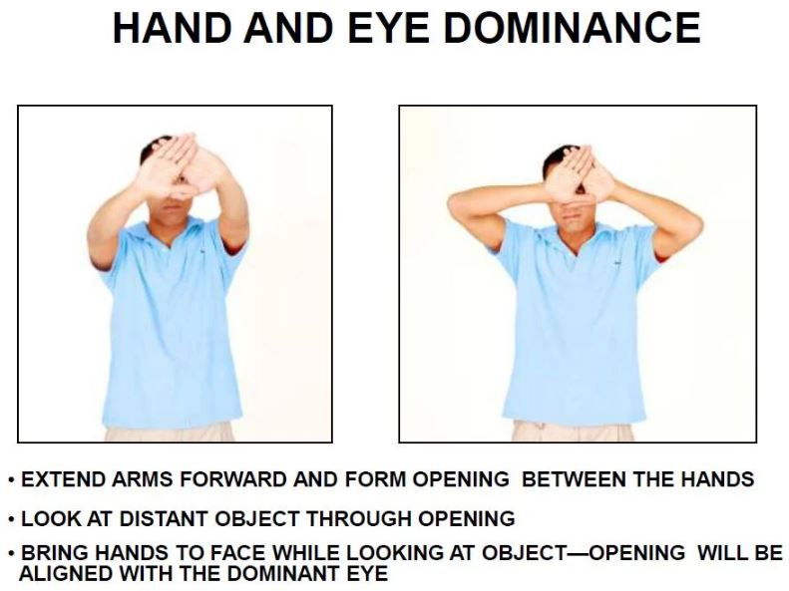
Eye Dominance |  | Shooting is best done with both eyes open if you are cross dominant we can explore options open to you

